PROJECT REPORT ON UNLEASHING THE POTENTIAL OF OUR YOUTH: A STUDENT PERFORMANCE ANALYSIS.

TEAM MEMBERS

**TEAMID:LTVIP2023TMID08284**

TEAM SIZE:5

TEAM LEADER: K.PUSHPALATHA

TEAM MEMBER : JANGIDI MADHURI

TEAM MEMBER : H.A VINAY

TEAM MEMBER : KAMMARA VISHNU

TEAM MEMBER : K.NAVITHA.

UNLEASHING THE POTENTIAL OF OUR YOUTH: A STUDENT PERFORMANCE ANALYSIS-

A country's growth is strongly measured by quality of its education system. Education sector, across the globe has witnessed sea change in its functioning. Today it is recognized as an industry and like any other industry it is facing challenges, the major challenges of higher education being decrease in students' success rate and their leaving a course without completion.

Analysing student work is an essential part of teaching. Teachers assign, collect and examine student work all the time to assess student learning and to revise and improve teaching. Ongoing assessment of student learning allows teachers to engage in continuous quality improvement of their courses. Many factors can influence a student's performance, including the influence of the parents' educational background, test preparation and so on.

The dataset contains the marks secured by 1000 students from a school. This project analyses and correlates student performance with different attributes. The analysis aims to understand the influence of important factors such as parental level of education, the status of test preparation course etc. on the performance of the students in the exams.

PROJECT FLOW-

* To accomplish this, we have to complete all the activities listed below,
* Define Problem / Problem Understanding

-> Specify the business problem-

-> Business requirement

->Literature Survey

->Social or Business Impact.

* Data Collection & Extraction from Database

.>>Collect the dataset,

>>Storing Data in DB2

>>Perform SQL Operations

>>Connect DB2 with Cognos

* Data Preparation

>>Prepare the Data for Visualization

* Data Visualizations

>>No of Unique Visualizations

* Dashboard

>>Responsive and Design of Dashboard

* Story

>>No of Scenes of Story

* Report

>>No of Visualization with detail information

* Performance Testing

>>Amount of Data Rendered to DB2

>>Utilization of Data Filters

>>No of Calculation Fields

>>No of Visualizations/ Graphs

* Web Integration

>>Dashboard, Report and Story embed with UI With Flask

Project Demonstration & Documentation

>>Record explanation Video for project end to end solution

>>Project Documentation-Step by step project development procedure.

**Define problem/problem understanding**

A problem statement is a clear and concise description of the issue or challenge that needs to be addressed. It should define the problem in a way that is understandable to stakeholders and provide a basis for developing a solution or course of action.

**Problem Statement:**

The challenge at hand is to comprehensively understand and address the factors influencing the performance and potential of the youth in educational settings. This problem centers around the need to analyze student performance in order to identify the underlying factors that hinder or facilitate their growth and development.

**Problem Understanding:**

1. **Student Performance Variability:** There is a significant variation in academic performance among students. Some excel while others struggle, and this variation can be attributed to a multitude of factors such as socioeconomic background, teaching methodologies, learning environment, personal motivation, and access to resources.

2. **Underlying Factors:** Unleashing the potential of youth requires a deep understanding of the factors that impact their performance. These factors may include family support, peer influence, quality of teaching, availability of extracurricular activities, mental health and well-being, and alignment of educational methods with individual learning styles.

3. **Equity and Accessibility:** Disparities in educational opportunities and resources can hinder the potential of youth. Students from disadvantaged backgrounds may face barriers such as limited access to quality education, technology, and support systems, impacting their overall performance and limiting their future prospects.

4. **Holistic Development:** Focusing solely on academic performance might overlook other crucial aspects of youth development. Holistic growth involves nurturing creativity, critical thinking, problem-solving abilities, emotional intelligence, and interpersonal skills, which collectively contribute to unleashing their full potential.

5. **Identifying Intervention Points:** To effectively address this problem, it's essential to identify intervention points. These are specific areas where changes, improvements, or support can be provided to enhance the overall learning experience and subsequently boost student performance and potential.

6. **Data-Driven Insights:** Utilizing data analytics and educational research can provide valuable insights into patterns of student performance. By examining trends over time and comparing data across diverse student groups, it's possible to identify trends and correlations that can inform evidence-based interventions.

7. **Tailored Approaches:** A one-size-fits-all approach is unlikely to succeed due to the diversity of student backgrounds and learning styles. Tailoring teaching methods, support systems, and resources to individual needs is crucial for optimizing student performance and realizing their potential.

8. **Long-Term Impact:** The goal of unleashing youth potential is not just short-term academic success, but also cultivating skills and mindsets that will serve them well beyond their educational years. This requires a focus on skills like adaptability, resilience, and lifelong learning.

In conclusion, the problem of unleashing the potential of our youth through student performance analysis is complex and multifaceted. It involves understanding the interplay of various factors that influence student performance, addressing disparities in educational opportunities, fostering holistic development, utilizing data-driven insights, and implementing tailored approaches. By addressing these aspects, we can work towards creating an educational environment that empowers every student to reach their full potential.

# Business Problem:

The business problem at hand revolves around optimizing the educational ecosystem to unleash the potential of youth through a focused student performance analysis. This problem directly impacts educational institutions, policymakers, and stakeholders with a vested interest in fostering the growth and development of the younger generation.

**\*\*Key Business Challenges:\*\***

1. **Educational Institution Reputation and Success:** Educational institutions, whether schools or colleges, are evaluated based on the academic performance of their students. Enhancing student performance not only contributes to the institution's reputation but also attracts students, parents, and funding.

2. **Student Enrollment and Retention:** A strong track record of nurturing student potential can positively influence student enrollment and retention rates. Parents and students are more likely to choose institutions that are known for producing well-rounded, successful graduates.

3. **Stakeholder Expectations:** Parents, guardians, and other stakeholders have high expectations regarding the quality of education and the outcomes it offers. Demonstrating a commitment to understanding and enhancing student performance aligns with these expectations.

4. **Economic Growth and Innovation:** A well-educated and empowered youth contributes significantly to a country's economic growth and innovation. Addressing the business problem can positively impact a nation's workforce quality, thereby fostering innovation and driving economic progress.

5. **Policy and Funding Allocation:** Policymakers and educational authorities make critical decisions based on student performance data. Effective analysis can provide insights that guide resource allocation, policy development, and curriculum enhancements.

6. **Skills for the Future Workforce:** As industries evolve, the demand for skills like critical thinking, creativity, and adaptability grows. Addressing the business problem involves equipping students with these skills, ensuring they are prepared for the challenges of the future job market.

7. **Competitive Advantage:** Institutions that successfully unleash student potential can gain a competitive advantage in the education sector. This advantage extends to producing graduates who are well-prepared to excel in various fields and contribute positively to society.

8. **Long-term Impact:** The business problem isn't just about short-term gains. It's about cultivating individuals who will become future leaders, innovators, and problem solvers. This long-term impact can shape the course of industries, communities, and nations.

Addressing the business problem involves a strategic approach to student performance analysis, encompassing data-driven insights, personalized learning strategies, equitable resource distribution, and the cultivation of skills beyond academics. By tackling these challenges, educational institutions and stakeholders can collaboratively work toward unleashing the potential of youth, thereby fostering a brighter future for individuals and society as a whole.

BUSINESS REQUIREMENTS

Certainly, here are some potential business requirements that would address the problem of unleashing the potential of youth through student performance analysis:

**\*\*1. Data Collection and Management:\*\***

- **Requirement:** Implement a robust data collection system to gather comprehensive student performance data, including academic grades, attendance records, extracurricular participation, and socio-economic background.

- **Rationale:** Accurate and diverse data is essential for conducting meaningful analysis and identifying factors affecting student performance.

**\*\*2. Analytics and Insights:\*\***

- **Requirement:** Develop advanced data analytics capabilities to uncover patterns, trends, and correlations within student performance data.

- **Rationale:** Data-driven insights will provide a deeper understanding of the factors influencing student performance, enabling evidence-based decision-making.

**\*\*3. Personalized Learning Strategies:\*\***

- **Requirement:** Design and implement personalized learning approaches that cater to individual learning styles and needs.

- **Rationale:** Personalized learning can enhance student engagement, motivation, and overall performance by tailoring education to students' strengths and weaknesses.

**\*\*4. Early Intervention Systems:\*\***

- **Requirement:** Create systems for identifying struggling students and implementing timely interventions, such as tutoring, counseling, or additional support.

- **Rationale:** Early intervention can prevent academic setbacks from escalating, ensuring that students receive the help they need to succeed.

**\*\*5. Equitable Resource Allocation:\*\***

- **Requirement:** Develop mechanisms to ensure equitable distribution of educational resources, including technology, teaching materials, and extracurricular opportunities.

- **Rationale:** Eliminating disparities in resource access fosters a level playing field for all students and contributes to improved performance.

**\*\*6. Holistic Development Framework:\*\***

- **Requirement:** Integrate a holistic development framework into the curriculum, focusing on soft skills, emotional intelligence, and character-building.

- **Rationale:** Holistic development equips students with skills beyond academics, making them well-rounded individuals prepared for future challenges.

**\*\*7. Collaboration Platforms:\*\***

- **Requirement:** Establish platforms for educators, students, parents, and counselors to collaborate and share insights on student progress and development.

- **Rationale:** Open communication channels facilitate a coordinated effort to support student growth and address challenges collectively.

**\*\*8. Continuous Monitoring and Evaluation:\*\***

- **Requirement:** Implement an ongoing monitoring and evaluation system to track the effectiveness of interventions and initiatives.

- **Rationale:** Regular assessment ensures that strategies are producing desired outcomes and allows for adjustments as needed.

**\*\*9. Professional Development for Educators:\*\***

- **Requirement:** Provide continuous professional development opportunities for educators to stay updated on effective teaching methods and strategies.

- **Rationale:** Well-trained educators are better equipped to engage students and create conducive learning environments.

**\*\*10. Long-Term Impact Measurement:\*\***

- **Requirement:** Define metrics to measure the long-term impact of education, including graduates' success in higher education, careers, and contributions to society.

- **Rationale:** Tracking graduates' achievements demonstrates the lasting effects of educational initiatives on unleashing their potential.

These business requirements provide a foundation for addressing the problem of unlocking the potential of youth through student performance analysis. By fulfilling these requirements, educational institutions and stakeholders can collaboratively work towards creating an environment that nurtures individual growth, maximizes student potential, and prepares them for a successful future.

# LITERACY SURVEY

It seems like you're interested in conducting a literacy survey. A literacy survey is a valuable tool for gathering information about the reading, writing, and comprehension skills of a particular group of people. Whether you're focused on a specific demographic, region, or age group, a well-designed literacy survey can provide insights into the literacy levels, challenges, and opportunities within that population. Here's a basic outline of how you could structure a literacy survey:

**1. Introduction:**

- Provide a brief overview of the purpose of the survey, highlighting the importance of literacy and its impact on various aspects of life.

**2. Demographic Information:**

- Gather basic demographic data to categorize respondents, such as age, gender, educational background, occupation, and location.

**3. Reading Habits:**

- Explore the respondents' reading habits by asking about the frequency of reading books, newspapers, online articles, and other written materials. - Inquire about preferred genres and formats.

**4. Writing Proficiency:**

- Assess respondents' writing skills by asking about their comfort level in writing emails, letters, essays, or other written forms.

- Inquire about any challenges they face when it comes to writing.

**5. Comprehension and Interpretation:**

- Include questions that gauge respondents' comprehension abilities, such as asking them to summarize a passage or answer questions based on a given text.

**6. Educational Background:**

- Obtain information about respondents' highest level of education completed, any ongoing education, and their experiences in educational institutions.

**7. Literacy Challenges:**

- Ask about any challenges or barriers they face in improving their literacy skills.

- Inquire about potential obstacles, such as lack of access to books, resources, or educational opportunities.

**8. Technological Literacy:**

- In today's digital age, it's essential to inquire about respondents' comfort with digital devices, online content, and their ability to navigate digital platforms.

**9. Literacy Support and Resources:**

- Explore whether respondents have access to libraries, educational programs, or literacy-related support networks.

**10. Perception of Literacy's Impact:**

- Ask respondents about their perceptions of how literacy impacts their personal and professional lives.

**11. Future Literacy Goals:**

- Inquire whether respondents have any specific goals related to improving their literacy skills and how they plan to achieve them.

**12. Open-Ended Questions:**

- Include a few open-ended questions to allow respondents to share additional insights, experiences, and suggestions.

**13. Data Privacy and Consent:**

- Clearly state how the collected data will be used, ensuring respondents' privacy and confidentiality. Obtain their consent to participate in the survey.

**14. Conclusion:**

- Thank respondents for their participation and provide information on how they can learn more about literacy initiatives or resources if interested.

**15. Data Analysis:**

- After collecting the survey responses, analyze the data to identify trends, challenges, and opportunities for improving literacy levels within the surveyed population.

Remember that the effectiveness of your literacy survey depends on clear and unbiased questions, as well as a diverse and representative sample of respondents. The insights gained from the survey can inform targeted interventions, educational programs, and policy changes aimed at enhancing literacy and unleashing the potential of individuals within the surveyed group.

Both social and business impact can result from addressing the issue of literacy through a survey and related initiatives. Let's explore how each type of impact could be realized:

# SOCIAL OR BUSINESS IMPACT:

1. **Improved Literacy Rates:** The primary social impact of a literacy survey and subsequent interventions is the potential to improve overall literacy rates within the surveyed population. By identifying challenges and tailoring solutions, you can contribute to enhancing reading, writing, and comprehension skills.

2. **Empowerment:** Literacy empowers individuals by enabling them to access information, communicate effectively, and make informed decisions. Improved literacy contributes to individuals' sense of agency and participation in social, economic, and political activities.

3. **Education Access:** Insights from the survey can help identify barriers to education and literacy, allowing for targeted efforts to increase access to quality education and resources, particularly for marginalized communities.

4. **Economic Mobility:** Literacy is often linked to economic opportunities. By addressing literacy challenges, you can help individuals enhance their employability, access higher-paying jobs, and break the cycle of poverty.

5. **Community Development:** Communities with higher literacy levels tend to be more engaged, cohesive, and capable of driving positive change. Improved literacy can foster community initiatives and collaboration.

6. **Health Literacy:** Literacy is connected to health literacy, enabling individuals to understand medical instructions, access healthcare resources, and make healthier lifestyle choices.

**Business Impact:**

1. **Workforce Readiness:** Businesses benefit from a well-literate workforce that can comprehend instructions, communicate effectively, and adapt to changing demands. Addressing literacy challenges can enhance the readiness of the workforce.

2. **Innovation and Problem Solving:** Literacy fosters critical thinking and creative problem-solving skills. Businesses can benefit from employees who can analyze information, propose solutions, and contribute to innovation.

3. **Customer Engagement:** For businesses that interact with customers, employees' literacy skills impact customer interactions, effective communication, and the ability to understand customer needs.

4. **Employee Training:** Addressing literacy challenges can positively impact employee training and development programs, as employees can more easily learn and apply new information.

5. **Corporate Social Responsibility (CSR):** Businesses that invest in literacy initiatives demonstrate a commitment to social responsibility and community development, enhancing their reputation and stakeholder relationships.

6. **Diversity and Inclusion:** Addressing literacy disparities can contribute to a more inclusive workplace, as efforts to support employees' skill development can promote diversity and equal opportunities.

In summary, addressing literacy challenges through a survey and related efforts can lead to both social and business impact. Socially, it empowers individuals, improves access to education, enhances community development, and contributes to overall well-being. From a business perspective, it enhances workforce readiness, innovation, customer engagement, and corporate social responsibility, ultimately benefiting the organization and the wider society.

>>> Data Preparation

Data modules are containers that describe data and rules for combining and shaping data to prepare it for analysis and visualization in IBM Cognos Analytics. Data module sources. Data modules can be based on data servers, packages, uploaded files, data sets, and other data modules

>>> Data Visualization

Data visualization is the process of creating graphical representations of data in order to help people understand and explore the information. The goal of data visualization is to make complex data sets more accessible, intuitive, and easier to interpret. By using visual elements such as charts, graphs, and maps, data visualizations can help people quickly identify patterns, trends, and outliers in the data.

>>> No Of Unique Visualizations

The number of unique visualizations that can be created with a given dataset. Some common types of visualizations that can be used to analyse the Literacy include bar charts, line charts, heat maps, scatter plots, pie charts, Maps etc. These visualizations can be used to compare and analyze students performance base on number of diffrent parameters.

1.male female pass ratio

2. students by grade

3. race specific distribution

4.parents education

5.test preparation effectiveness

6.grades based on preparationa material

7.race wise pass fail ratio

>>>Dashboard

A dashboard is a graphical user interface (GUI) that displays information and data in an organized, easy-to-read format. Dashboards are often used to provide real-time monitoring and analysis of data, and are typically designed for a specific purpose or use case. Dashboards can be used in a variety of settings, such as business, finance, manufacturing, healthcare, and many other industries. They can be used to track key performance indicators (KPIs), monitor performance metrics, and display data in the form of charts, graphs, and tables.

### Responsive And Design Of Dashboard

The responsiveness and design of a dashboard for Data-Driven insights on Student Performance is crucial to ensure that the information is easily understandable and actionable. Key considerations for designing a responsive and effective dashboard include user-centered design, clear and concise information, interactivity, data-driven approach, accessibility, customization, and security. The goal is to create a dashboard that is user-friendly, interactive, and data-driven, providing actionable insights.

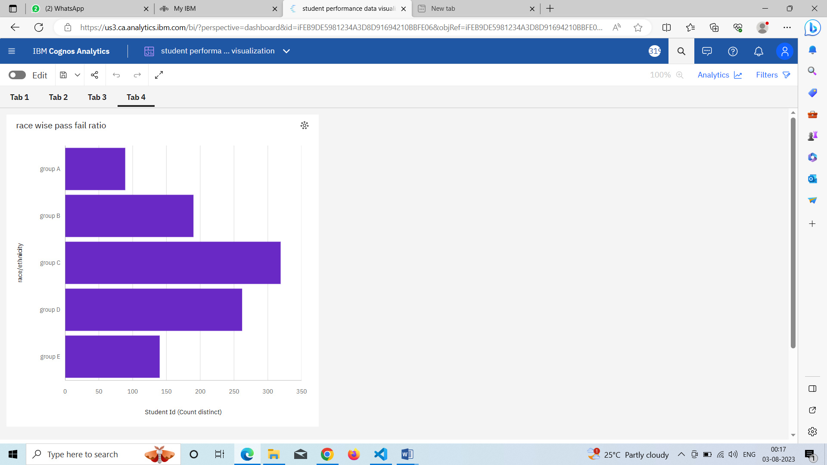

### 

### Story

### A data story is a way of presenting data and analysis in a narrative format, with the goal of making the information more engaging and easier to understand. A data story typically includes a clear introduction that sets the stage and explains the context for the data, a body that presents the data and analysis in a logical and systematic way, and a conclusion that summarizes the key findings and highlights their implications. Data stories can be told using a variety of mediums, such as reports, presentations, interactive visualizations, and videos.

### >>>No Of Scenes Of Story

The number of scenes in a storyboard for Data-Driven insights on Students Performance will depend on the complexity of the analysis and the specific insights that are trying to be conveyed. A storyboard is a visual representation of the data analysis process and it breaks down the analysis into a series of steps or scenes.

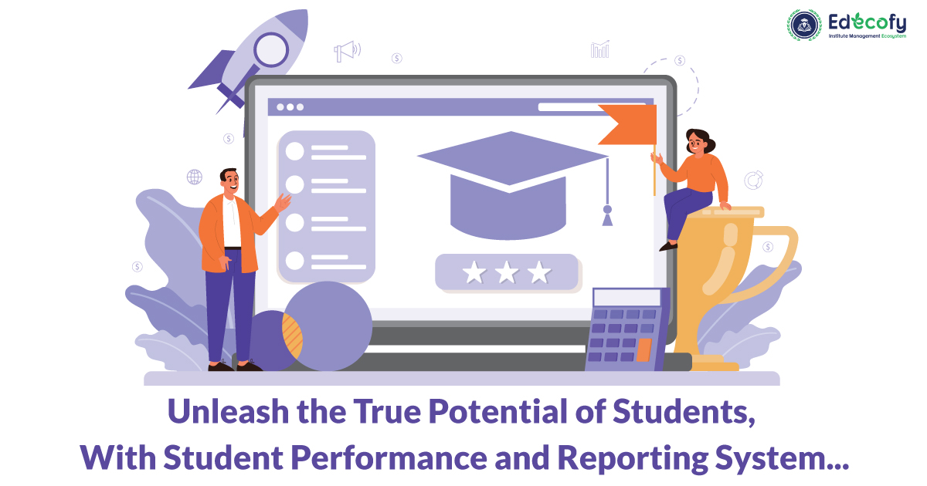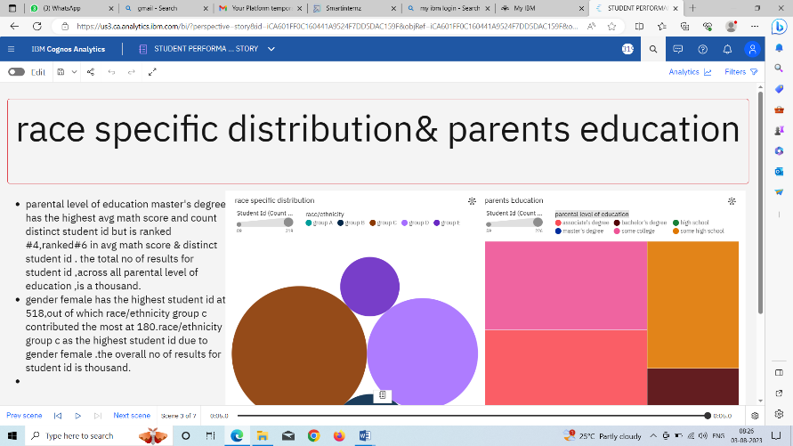

Report

A report in data analytics typically involves analysing and interpreting data to draw insights and conclusions that can inform business decisions or address research questions. The report usually includes a summary of the data analysis process, including the methods and tools used, as well as the findings and recommendations based on the analysis. The report should begin with an executive summary, which provides a brief overview of the main findings and recommendations. The introduction should provide background information on the problem or research question being addressed and the data sources used.

### No Of Visualization With Detailed Information

When creating a report in Cognos, it is often helpful to include visualizations to help communicate the findings of the analysis.

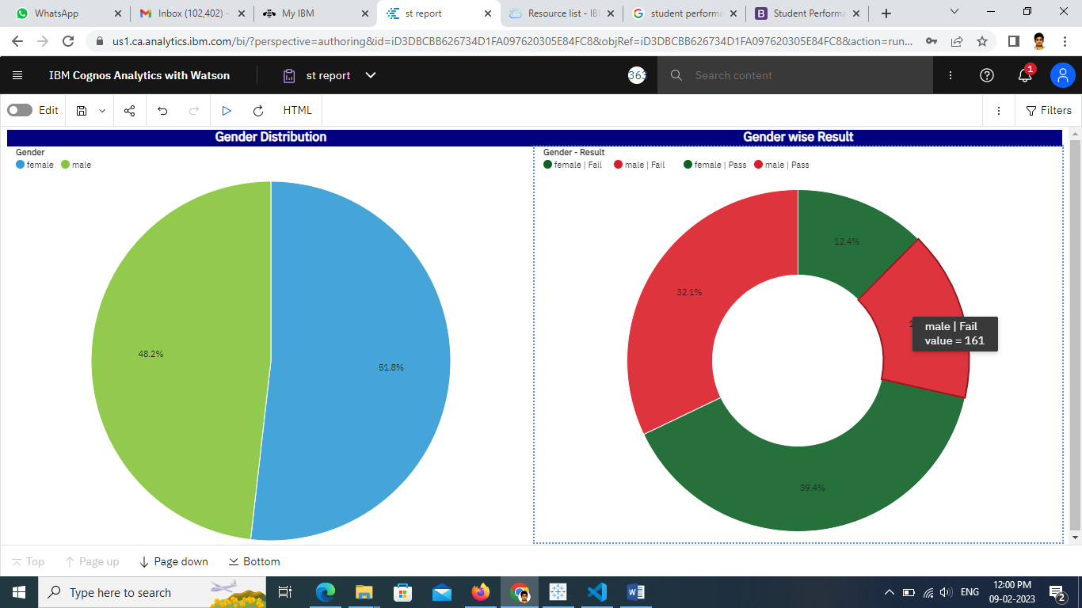

### Performance Testing

We'll be testing the prformance of our project.

### No Of Visualizations/ Graphs

1. Male Female Pass Ratio
2. Students By Grade
3. Race Specific Distribution
4. Parents Education
5. Test Preparation Effectiveness
6. Grades Based on Preparation Material
7. Race Wise Pass-Fail Ratio.

Web Integration

Publishing helps us to track and monitor key performance metrics, to communicate results and progress. help a publisher stay informed, make better decisions, and communicate their performance to others.

**Publishing dashboard, report & story.**

Step 1: Go to Dashboard, report & /story, click on share button on the top.

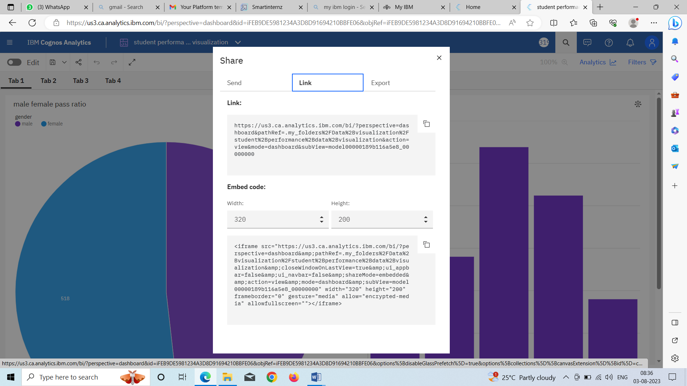

### Dashboard, Report And Story Embed With UI With Flask

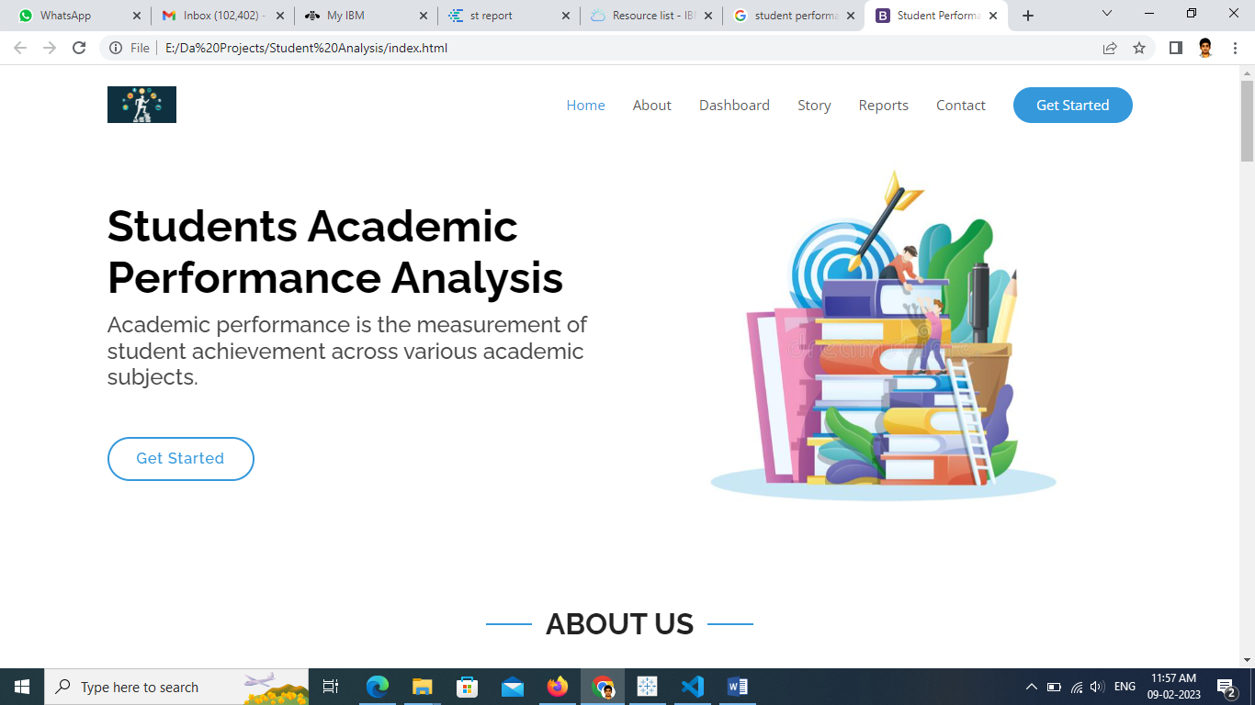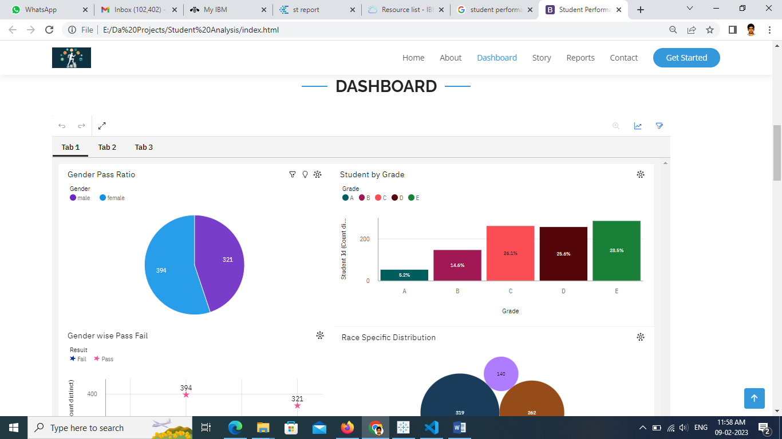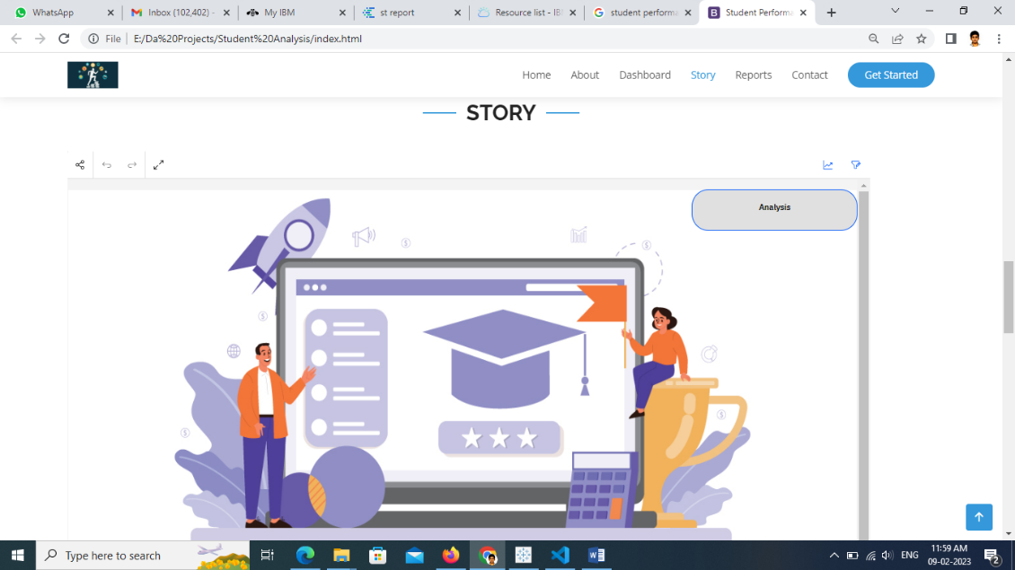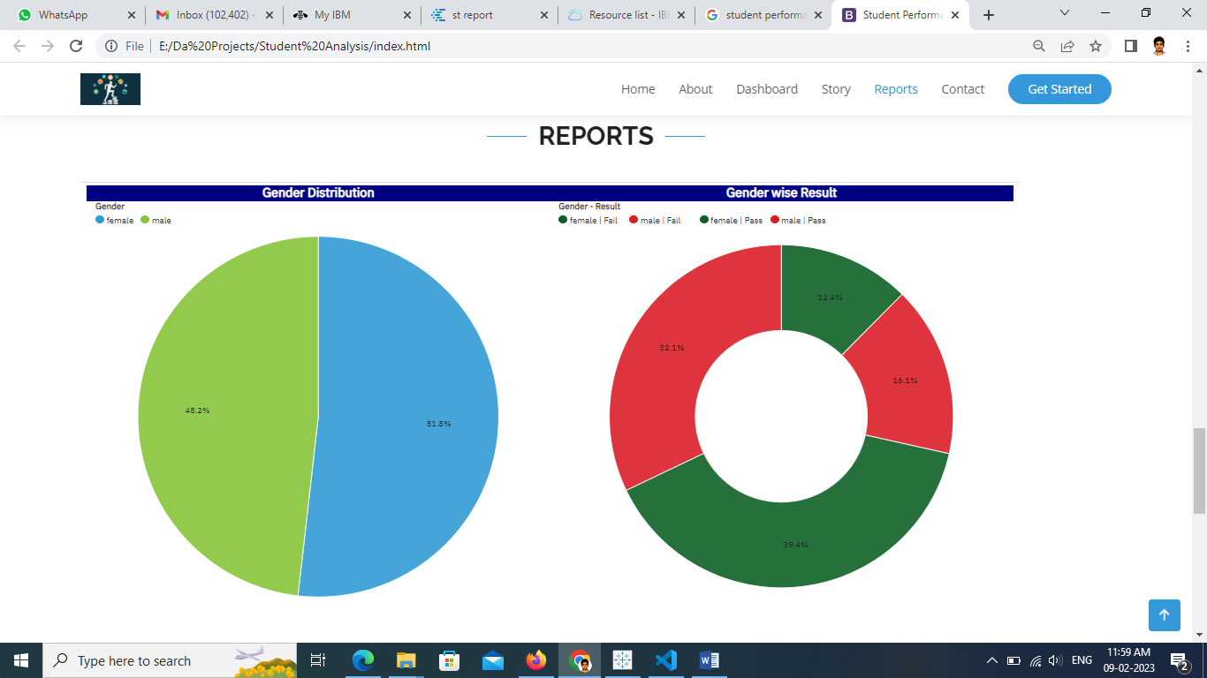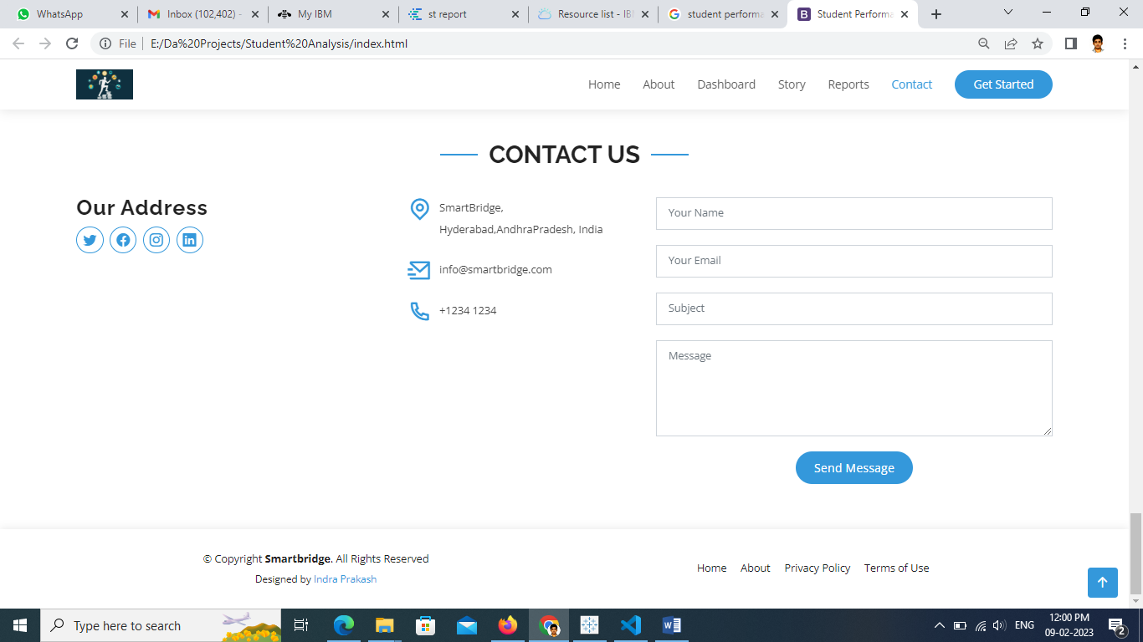

Conclusion: